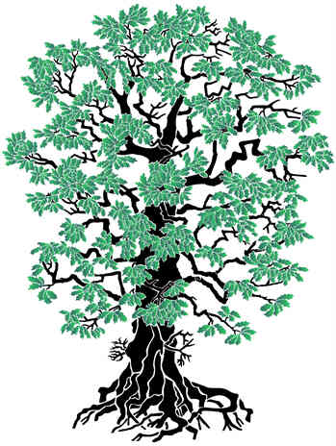***FAMILY TREE***

grand- parents

parents

grand-parents = starí rodičia

parents = rodičia

kids = deti ( bratia a sestry )

me = ja (dieťa)

me

kids

dad

mum

grandpa 2

grandma 2

grandma 1

grandpa 1