Vocabulary – which food do you like?
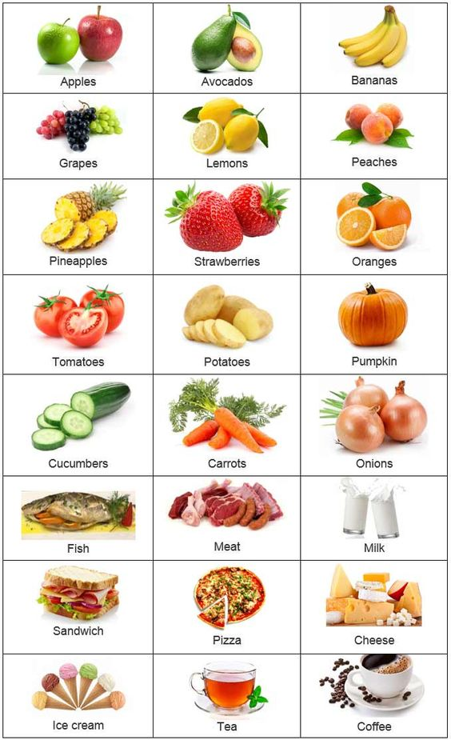

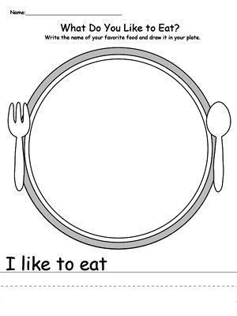
napíš svoje obľúbené jedlo a nakresli ho na tanier
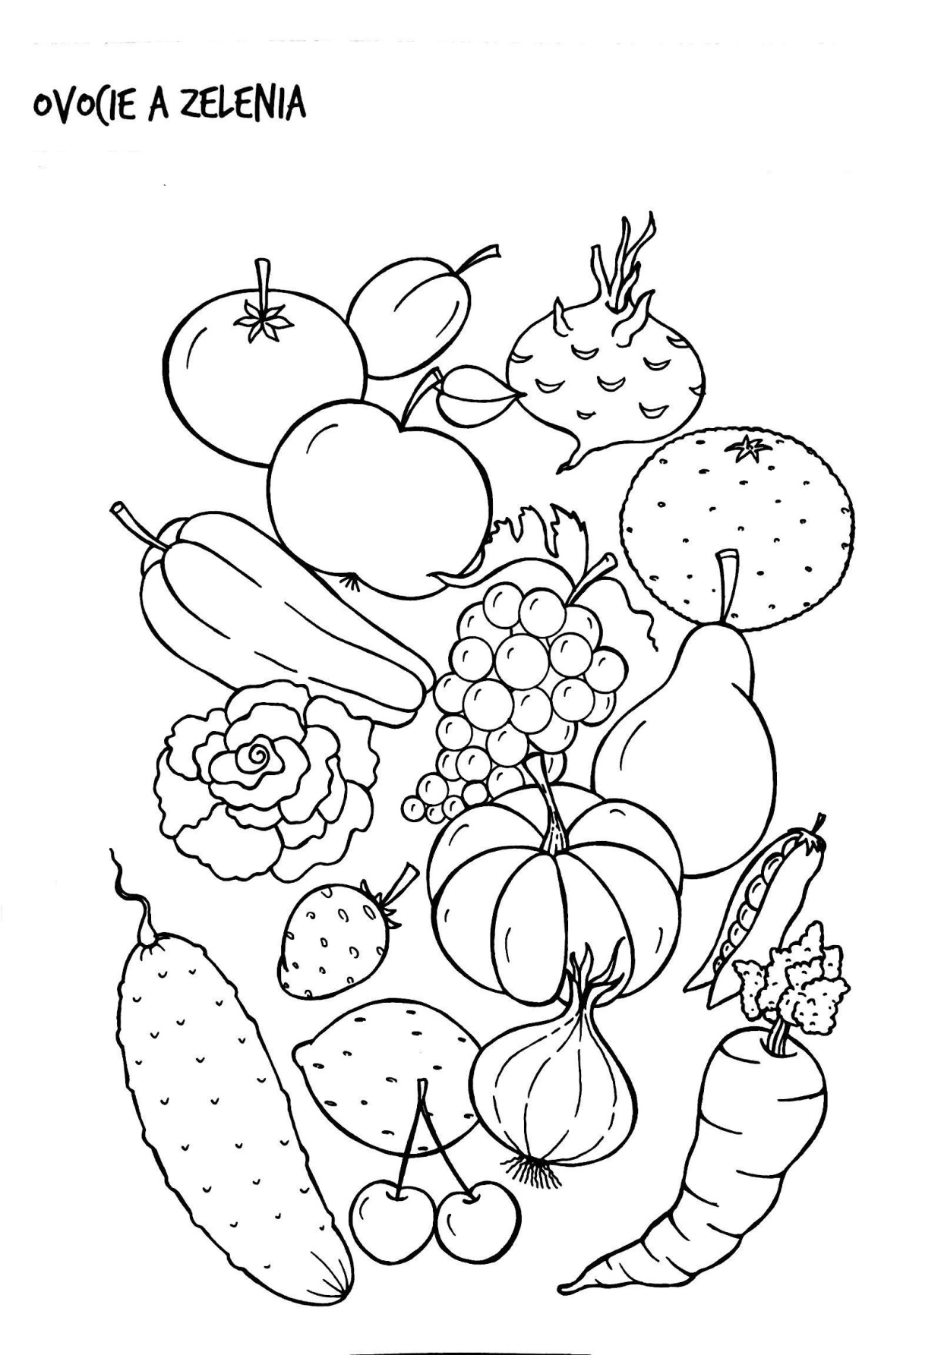
Colour fruits and vegetables/ vyfarbi

